UMass Graduate Nalida L Besson Works with Tech Goes Home to Support
Boston-based Students who are Blind Access iPads

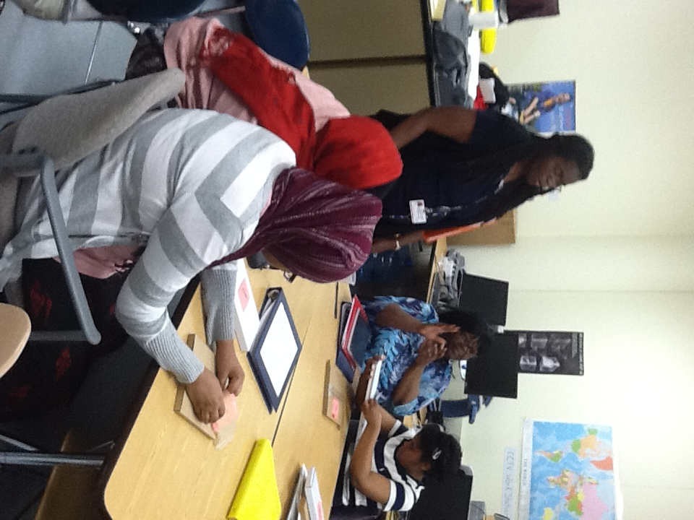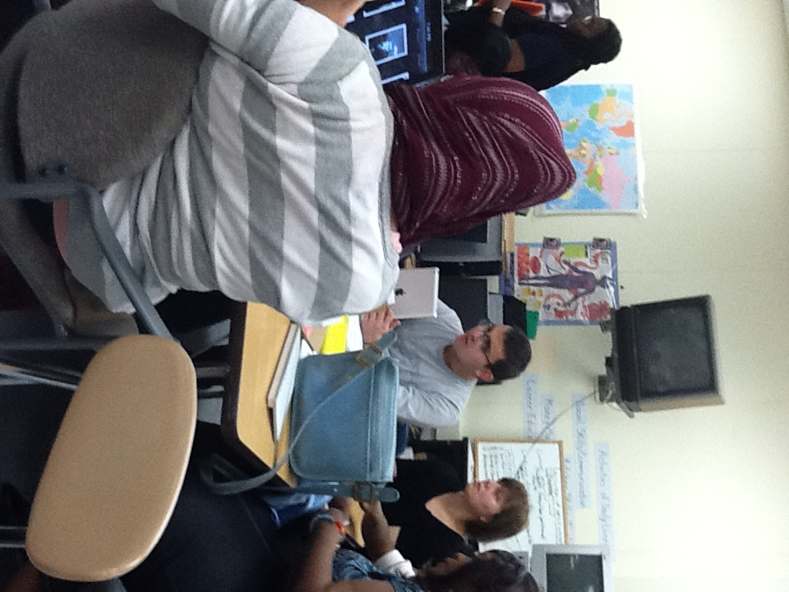
Instructor Nalida Besson and students in the 2011—2012 school year TGH iPad class.

Tech Goes Home (TGH) is a non-profit organization that helps to put technology in the hands of students and families in Boston. 75% of adults who participate in the program earn less than $25,000 per year. 70% had never attended a school event but after participating in TGH, 98% will remain connected to the school.

TGH has always worked with students with and without disabilities. However, last year TGH specifically wanted to reach out to students who are blind and visually impaired so that those students would be able to access mainstream technology. One of Boston Public School’s TVIs Nalida L. Besson developed a curriculum and taught a six-week, 15-hour course to 12 blind/VI students and their parents and guardians. Students learned how to access the iPad via VoiceOver and Zoom to email, do internet searches, write using note applications, as well as create video content. Students were able to receive training materials in large print as well as braille. At the end of the six weeks, each student received a new iPad!

TGH will continue this class for the 2012—2013 school year and needs to raise funds for such a unique class. Students in the TGH programs generally receive a netbook. However, the students who are blind receive an iPad which they can access with the built in accessibility features that they learn during the session. Anyone who can contribute to this program to offset the cost of the class may do so with the link below.

http://www.citizinvestor.com/project/connecting-blind-children-with-tech

For more information on TGH, please visit their website at http://www.techgoeshome.org/.

